УО «Белорусский государственный университет информатики и радиоэлектроники»

Кафедра ПОИТ

Отчет по лабораторной работе №1.1

по предмету «Основы алгоритмизации и программирования»

Вариант 20

Выполнил:

Егоров А.С.

Гр. 351005

Проверил:

Данилова Г. В.

Минск 2023

**Задание:**

Ввести два положительных числа и показать, что среднее арифметическое этих чисел не меньше их среднего геометрического.

**Код программы Delphi:**

Program Exercise1;

Uses

System.SysUtils, Math;

// initialization

Var

Num1: Real = 0;

Num2: Real = 0;

ArithmeticAvg: Real = 0;

GeometricAvg: Real = 0;

GoodFlag: Boolean = False;

Begin

// output the task

Writeln(' The program is proving that arithmetic average of two unsigned');

Writeln('double numbers bigger or equal than geometric average of this numbers.');

Writeln;

// loop for check inputted symbols

Repeat

Try

Begin

// input in console

Writeln('Enter first unsigned double number:');

Readln(Num1);

If Num1 < 0 Then

Raise Exception.Create

('Entering number cannot be less than 1!!!');

Writeln('Enter second unsigned double number:');

Readln(Num2);

If Num2 < 0 Then

Raise Exception.Create

('Entering number cannot be less than 1!!!');

// to exit the loop if user entered correct symbols

GoodFlag := True;

End;

Except

On E: Exception Do

Begin

Write(E.Message);

Writeln(' Try again.');

Writeln;

End;

End;

Until (GoodFlag);

// main block

ArithmeticAvg := (Num1 + Num2) / 2;

GeometricAvg := Sqrt(Num1 * Num2);

// ouput console

Writeln;

Writeln('Arithmetic average: ', ArithmeticAvg:1:4);

Writeln('Geometric average: ', GeometricAvg:1:4);

If ArithmeticAvg = GeometricAvg Then

Writeln('Arithmetic average = Geometric average')

Else

Writeln('Arithmetic average > Geometric average');

// freeze console

Writeln('Press Enter to exit...');

Readln;

End.

**Код программы С++:**

#include<math.h>

#include<iomanip>//for foramtting output data

int main()

{

//initialization

double num1 = 0, num2 = 0, arithmeticAvg = 0, geometricAvg = 0;

bool goodFlag = false; // for loop if wrong input

//output the task

std::cout << " The program is proving that arithmetic average of two unsigned\n"

<< "double numbers bigger or equal than geometric average of this

numbers.\n\n";

//loop for check inputted symbols

do

{

try

{

//input

std::cout << "Enter first unsigned double number:\n";

std::cin >> num1;

if (std::cin.get() != '\n') // if there's a char instead of double

{

std::cin.clear();

std::cin.ignore(32767, '\n');

throw std::exception("Invalid type!!!");

}

if (num1 < 0)

throw std::exception("Entering number cannot be less than 1!!!");

std::cout << "Enter second unsigned double number:\n";

std::cin >> num2;

if (std::cin.get() != '\n') // if there's a char instead of double

{

std::cin.clear();

std::cin.ignore(32767, '\n');

throw std::exception("Invalid type!!!");

}

if (num2 < 0)

throw std::exception("Entering number cannot be less than 1!!!");

goodFlag = true; // to exit the loop if user entered correct symbols

}

catch (const std::exception& ex)

{

std::cout << ex.what() << " Try again.\n\n";

}

} while (!goodFlag);

//main block

arithmeticAvg = (num1 + num2) / 2;

geometricAvg = sqrt(num1 * num2);

//output

std::cout << "\nArithmetic average: " << arithmeticAvg

<< "\nGeometric average: " << std::fixed << std::setprecision(4) << geometricAvg

<< ((arithmeticAvg == geometricAvg)

? "\nArithmetic average = Geometricaverage\n"

: "\nGeometric average > Arithmetic average\n");

return 0;

}

**Код программы Java:**

import java.util.Scanner;  
import java.lang.Math;  
  
//main class  
public class Main  
{  
 public static void main(String[] args)  
 {  
 //initialization  
 double num1 = 0, num2 = 0, arithmeticAvg = 0, geometricAvg = 0;  
 boolean goodFlag = false;  
 //output the task  
 System.out.println(" The program is proving that arithmetic average of two

unsigned \n"  
 + "double numbers bigger or equal than geometric average of this

numbers.\n");  
 //loop for check inputted symbols  
 do {  
 try  
 {  
 //input  
 System.out.println("Enter first unsigned double number:");  
 Scanner in = new Scanner(System.in);  
 num1 = in.nextDouble();  
 if (num1 < 0)  
 throw new Exception("It's impossible to solve this exercise with

num1 < 0!!!");  
 System.out.println("Enter second unsigned double number:");  
 num2 = in.nextDouble();  
 if (num2 < 0)  
 throw new Exception("It's impossible to solve this exercise with

num2 < 0!!!");  
 goodFlag = true; // to exit the loop if user entered correct symbols  
 in.close();  
 }  
 catch (Exception ex)  
 {  
 if (ex.getMessage() == null)  
 System.out.println("Invalid type!!!" + " Try again.");  
 else  
 System.out.println(ex.getMessage() + " Try again.");  
 }  
 } while (!goodFlag);

//main block  
 arithmeticAvg = (num1 + num2) / 2;  
 geometricAvg = Math.sqrt(num1 * num2);

//output  
 System.out.printf("""  
 Arithmetic average: %f  
 Geometric average: %f  
 """, arithmeticAvg,geometricAvg);  
 if (arithmeticAvg == geometricAvg)  
 System.out.println("Arithmetic average = Geometric average");  
 else  
 System.out.println("Arithmetic average > Geometric average");  
 }  
}

**Скриншоты:**

**Delphi:**

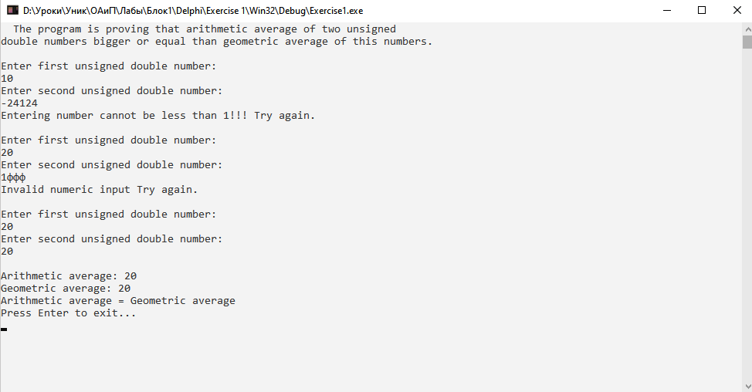

**C++:**

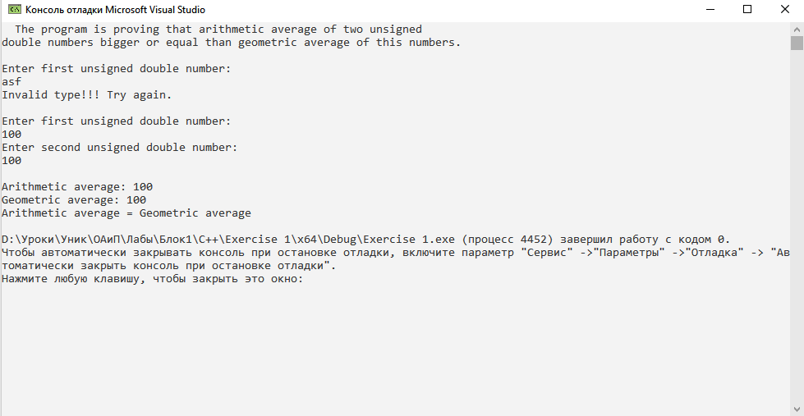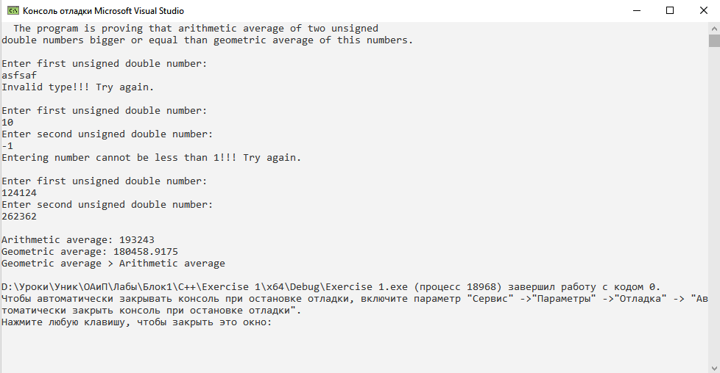

**Java:**

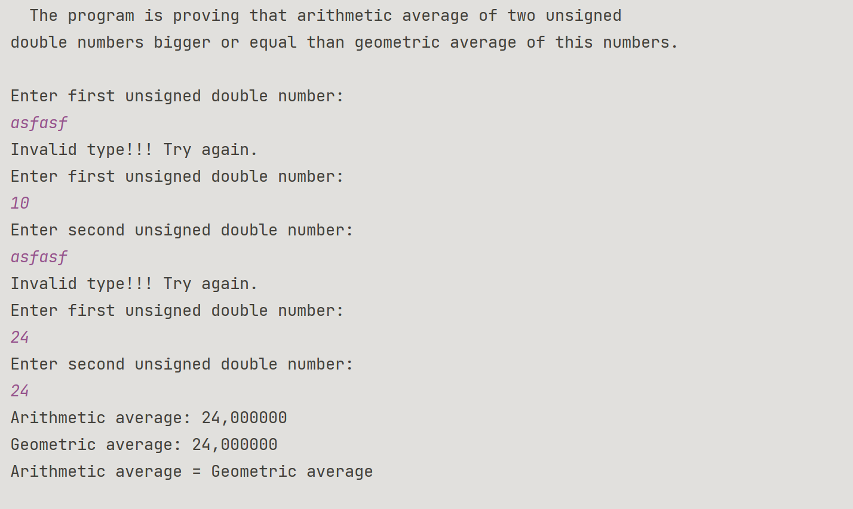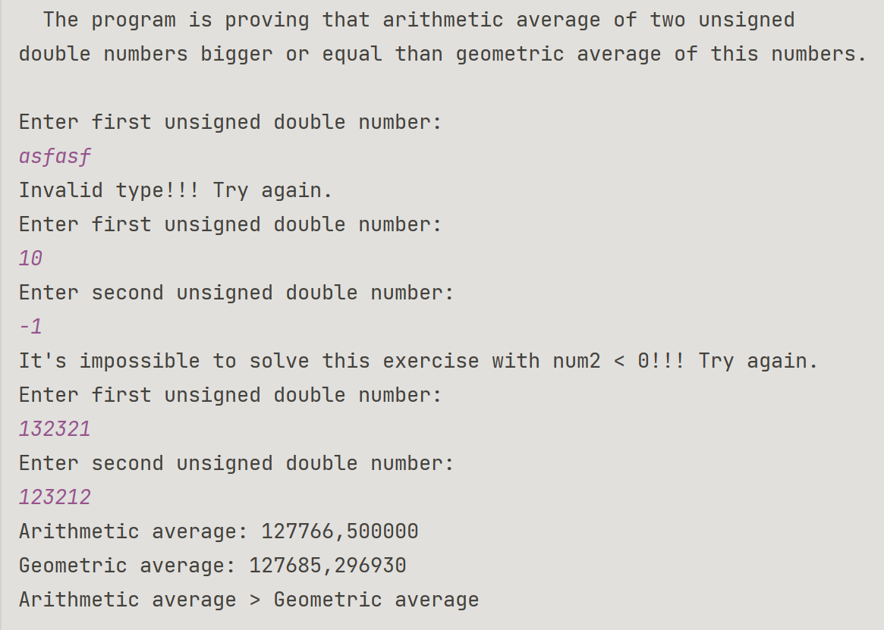

**Блок-схема:**

